Sprint 2 Materials
Team A



Grant Ashford
Brenden Barber
Leo Cuzela
Ryan Roeling
Sam Scarcelli
Jared Spotts

Retrospective Summary
Throughout Sprint 2, as a team, we were able to make the progress needed to move onto Sprint 3 and finish this project up successfully. Just like within Sprint 2, we were not able to complete all the tasks that were listed on the product backlog, but feel pleased with the direction we are heading in for the goal we want to achieve for Sprint 3. Also, the things that went right within Sprint 2, were that we were able to implement both the Google OAuth 2 and the Google Translate API features required for this project, along with choosing an API that had to be approved by a TA/Professor, x-report being resolved and payment screen being fulfilled for the kiosk. Additionally, we felt that we could have done better on the scheduling part for this sprint, similar to Sprint 1, and with Thanksgiving break approaching, we need to make sure we are on the same page about the progress that should be made after we get back from Thanksgiving break. After getting the issues resolved with troubleshooting and github within Sprint 1, we felt like we have been more efficient for Sprint 2, regarding tasks completed in Sprint 2 versus Sprint 1. Other than that, we know the importance of picking up the pace a little bit for Sprint 3 in order to complete this project effectively and efficiently to be able to achieve our goal of having a fully functional web application that includes a variety of accessibility features.

GitHub Release Link

Product Backlog

Task | Sprint | Owner | Description | Priority | Dependencies | Story Points | Complete
1 | 1 | Leo | Set up project using React.js | 1 | 14 | 1 | O
2 | 1 | Grant | Update manager x-report | 2 | 3 | 1 | /
3 | 1 | Ryan | Update Manager Database interaction | 2 |  | 2 | X
4 | 1 | Brenden | Connect Kiosk View to database | 3 |  | 2 | O
5 | 1 | Leo | Configure Javascript/AWS Connectivity using ENV file | 3 |  | 2 | O
6 | 1 | Leo | Set up GitHub to Hosting platform integration | 1 |  | 1 | O
7 | 1 | Sam | Brainstorm thematic features | 4 |  | 1 | O
8 | 1 | Grant | Implement Kiosk UI | 3 |  | 3 | /
9 | 1 | Brenden | Implement thematic features for customer interface | 4 | 7,8 | 2 | O
10 | 1 | Brenden | Create branch strategies | 2 |  | 1 | O
11 | 1 | Jared | Write appropriate README | 5 |  | 1 | X
12 | 1 | Ryan | Add order status column to order table | 2 |  | 1 | O
13 | 1 | Jared | Update UML | 5 |  | 1 | X
14 | 1 | Leo | Set up Docker Environment | 1 |  | 2 | O
15 | 1 | Sam | Update Manager Documentation | 5 | 17 | 1 | X
16 | 1 | Sam | Create Kiosk Documentation | 5 | 9 | 1 | X
17 | 1 | Brenden | Perform Code Reviews for Manager | 4 | 2 | 1 | O
18 | 1 | Ryan | Seed database with test data | 2 | 12 | 1 | X
19 | 1 | Ryan  (Jared) | Connect Kitchen View to database | 3 |  | 1 | X
20 | 1 | Jared | Make kitchen display retrieve pending orders from database | 4 | 19 | 1 | X
21 | 1 | Brenden | Make kitchen display in progress orders | 4 | 12,20 | 1 | O
22 | 1 | Ryan | Make functionality to change order status | 5 | 21 | 2 | X
23 | 2 | Sam | Update login screen | 5 |  | 2 | O
24 | 2 | Sam | Test and Debug GUI | 5 | 8,25 | 3 | O
25 | 2 | Grant | Update user authentication UI | 5 | 8 | 3 | X
26 | 2 | Leo | Establish endpoints with weather | 1 |  | 2 | O
27 | 2 | Leo | Establish endpoints with translation | 1 |  | 2 | O
28 | 2 | Ryan | Establish endpoints with choice API | 1 |  | 2 | X
29 | 2 | Ryan | Integrate Google OAuth 2 for login | 2 | 25 | 2 | O
30 | 2 | Sam | Integrate Google Translate for kiosk | 2 | 27 | 2 | O
31 | 2 | Leo | Integrate OpenWeather API for weather display | 2 | 26 | 2 | O
32 | 2 | Jared | Choose an API | 1 |  | 1 | O
33 | 2 | Grant | Implement screen reader support | 4 | 8 | 2 | X
34 | 2 | Sam | Add color contrast | 4 | 8 | 1 | O
35 | 2 | Sam | Add scalable text | 4 | 8 | 2 | O
36 | 2 | Brenden | Document issues for task tracking | 2 |  | 1 | X
37 | 2 | Ryan | Adapt cashier GUI | 1 |  | 1 | O
38 | 2 | Ryan | Add accessibility option (interface) | 3 | 8 | 2 | O
39 | 2 | Jared | Make dynamic menu | 4 |  | 3 | X
40 | 2 | Jared | Make multi-display feature | 4 |  | 3 | X
41 | 2 | Grant | Create Menu Documentation | 5 | 40 | 1 | X
42 | 2 | Brenden | Implement new login validation logic | 2 | 25 | 2 | O
43 | 2 | Leo | Perform Code Reviews for kiosk | 5 | 30 | 2 | O
44 | 2 | Jared | Integrate chosen API | 2 | 32 | 3 | X
45 | 3 | Ryan | Connect Menu board to database | 4 |  | 1 | X
46 | 3 | Leo | Audit for WCAD 2.1 compliance | 5 | 38 | 2 | X
47 | 3 | Brenden | Test with required and chosen personas | 5 | 38 | 1 | /
48 | 3 | Grant | Add payment screen | 1 | 43 | 2 | O
49 | 3 | Jared | Integrate dynamic menus into multi-display | 1 | 39,40 | 3 | X
50 | 3 | Grant | Create Kitchen Documentation | 4 | 21 | 1 | X
51 | 3 | Jared | Perform Code Reviews for Kitchen | 5 | 50 | 2 | X
52 | 3 | Brenden | Perform Code Reviews for Menu Board | 5 | 49 | 2 | X
53 | 3 | Ryan | Test live deployment | 5 | everything | 2 | X
54 | 1 | Jared | Reformat Manager view from Project 2 into javascript | 2 |  | 1 | O
55 | 1 | Grant | Implemented Kiosk UI MVP | 3 |  | 3 | O
56 | 2 | Grant | Fix X report for manager View | 3 | 54 | 2 | O
57 | 3 | Jared | Make the implement menu board weather integration | 5 | 49 | 3 | X
58 | 3 | Leo | Implement point system | 5 |  | 2 | X
59 | 3 | Ryan | Make Google OAuth sign users into different views based on role | 2 |  | 3 | X

Sprint Backlog

23 | 2 | Sam | Update login screen | 5 |  | 2 | O
24 | 2 | Sam | Test and Debug GUI | 5 | 8,25 | 3 | O
25 | 2 | Grant | Update user authentication UI | 5 | 8 | 3 | X
26 | 2 | Leo | Establish endpoints with weather | 1 |  | 2 | O
27 | 2 | Leo | Establish endpoints with translation | 1 |  | 2 | O
28 | 2 | Ryan | Establish endpoints with choice API | 1 |  | 2 | X
29 | 2 | Ryan | Integrate Google OAuth 2 for login | 2 | 25 | 2 | O
30 | 2 | Sam | Integrate Google Translate for kiosk | 2 | 27 | 2 | O
31 | 2 | Leo | Integrate OpenWeather API for weather display | 2 | 26 | 2 | O
32 | 2 | Jared | Choose an API | 1 |  | 1 | O
33 | 2 | Grant | Implement screen reader support | 4 | 8 | 2 | O
34 | 2 | Sam | Add color contrast | 4 | 8 | 1 | O
35 | 2 | Sam | Add scalable text | 4 | 8 | 2 | O
36 | 2 | Brenden | Document issues for task tracking | 2 |  | 1 | O
37 | 2 | Ryan | Adapt cashier GUI | 1 |  | 1 | O
38 | 2 | Ryan | Add accessibility option (interface) | 3 | 8 | 2 | O
39 | 2 | Jared | Make dynamic menu | 4 |  | 3 | X
40 | 2 | Jared | Make multi-display feature | 4 |  | 3 | X
41 | 2 | Grant | Create Menu Documentation | 5 | 40 | 1 | X
42 | 2 | Brenden | Implement new login validation logic | 2 | 25 | 2 | O
43 | 2 | Leo | Perform Code Reviews for kiosk | 5 | 30 | 2 | O
44 | 2 | Jared | Integrate chosen API | 2 | 32 | 3 | X
48 | 2 | Grant | Add payment screen | 1 | 43 | 2 | O
56 | 2 | Grant | Fix X report for manager View | 3 | 54 | 2 | O

NAME: | Leo | Jared | Grant | Sam | Brenden | Ryan
SPRINT 2 POINTS: | 8 | 1 | 6 | 10 | 3 | 5

Burn-down Charts

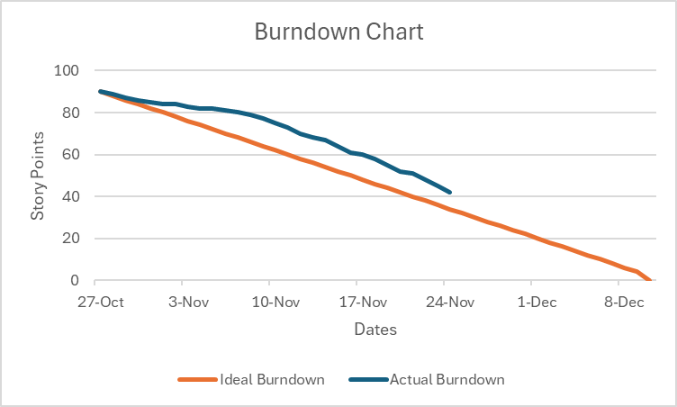
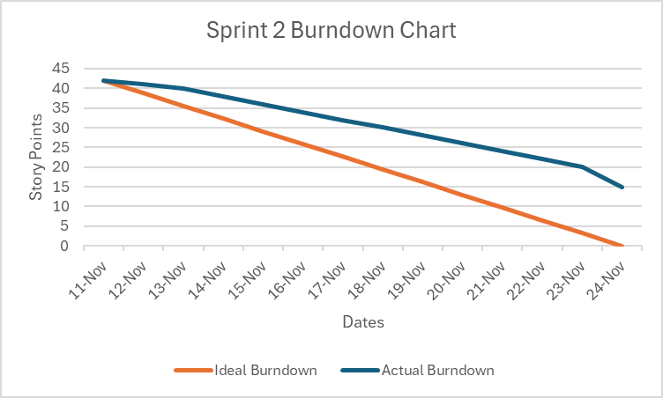

Sprint Test Plan
The following points summarize our Sprint 2 testing approach:
- Testing in Sprint 2 focused on verifying that each completed Sprint 2 backlog item met its defined acceptance criteria.
- Acceptance criteria was formed by taking into account
  - Accessibility
  - User personas
  - User experience
  - Functionality
- After each merge into the main branch, team members tested the updated Vercel deployment to validate Sprint 2 changes.
- This process allowed the team to identify and resolve issues, especially within the kiosk, which contained the highest number of interconnected features and required the most thorough verification.
Below are completed Sprint 2 tasks and their regression testing acceptance criteria:

- Update login screen
  - Ensure UI accurately functions
  - Ensure login screen properly redirects user
  - Ensure private areas cannot be accessed without proper credentials
- Test and Debug GUI
  - Test the accessibility features by interacting with all three personas in mind
  - Place orders and interact with the kiosk
  - Examine the manager view and test out present functions
- Establish endpoints with weather
  - Ensure weather data is accurate
  - Ensure weather data is updating in real time
- Establish endpoints with translation
  - Ensure connectivity with Google Translate APIs
  - Ensure translation functions on server side
- Integrate Google OAuth 2 for login
  - Ensure that the proper API keys required for login are saved to the .env file
  - Enforce email sign-in for workers that is to be saved to the database
- Integrate Google Translate for kiosk
  - Test responsiveness of translation button
  - Ensure selected text is translated correctly on screen
  - Ensure translated text does not distort the user interface
- Integrate OpenWeather API for weather display
  - Ensure that the proper API keys are saved to the .env file
  - Ensure weather display accurately reflects provided weather conditions
  - Ensure weather display does not interfere with the rest of Kiosk UI
- Choose an API
  - Determine what API would have creative benefits and implementation for our kiosk
  - Implement appropriate use of API in kiosk and other facets of the POS application
- Implement screen reader support
  - Ensure that the button is responsive for the reader
  - Check that the narration matches the text
- Add color contrast
  - Examine the color contrast mode’s readability
- Add scalable text
  - Ensure text scaling is reasonably large
  - Ensure scaled text fulfills accessibility criteria
  - Ensure scaled text satisfies user persona requirements
- Document issues for task tracking
  - Each team member has communicated their activity for the current sprint
  - Activity is properly updated in product and sprint backlog
- Adapt cashier GUI
  - Ensure all functionality from the cashier view in project 2 is translated over to a Javascript page
  - Verify that cashier UX is seamless for high volume customer transactions
- Add accessibility option (interface)
  - Test that the accessibility feature activates and functions as expected
  - Interact with the different features and modes
- Implement new login validation logic
  - Attempt logging in with valid credentials
  - Attempt logging in with invalid credentials
- Perform Code Reviews for kiosk
  - Interact with the kiosk and inspect the code, make notes on missing features
- Add payment screen
  - Ensure that the payment screen sends orders to kitchen
  - Ensure that customers can select items and add them to the cart
- Fix X report for manager view
  - Ensure that fixing the x-report for manager view as a textual version does not conflict with the other features
  - Ensure that the functionality of manager view works as intended after order placed in kiosk

Next Sprint’s SCRUM Meeting Schedule
Sprint 3:

Date | Time | Location
12/1 (SCRUM Meeting) | 2:25PM - 2:40PM | In lab
12/3 | 2:25PM - 2:40PM | In lab
12/5 (SCRUM Meeting) | 2:00PM - 2:15PM | Outside of class
12/7 (SCRUM Meeting) | 2:00PM - 2:15 PM | Outside of class
12/8 (SCRUM Meeting) | 9:45AM - 10:00AM | In class

Appendix 1: SCRUM Meeting Agendas and Minutes

SCRUM Meeting 4 for Project 3
Prepared by: Grant Ashford
Meeting Date: 11/12

Meeting Attendees
- Grant Ashford
- Brenden Barber
- Ryan Roeling
- Sam Scarcelli
- Jared Spotts
- Leo Cuzela

Meeting Agenda Items
- Review and make adjustments for sprint 2 plan.

Status Update Since Last Meeting
Accomplishments:
- Completed tasks for Sprint 1 deadline.

Tasks Completed:
Task Description | Assigned to | Completed? (yes/no)
Add scalable text | Sam | Yes
Add color contrast | Sam | Yes
Connect Kitchen View to database | Ryan | No
Make kitchen display in progress orders | Brenden | Yes

Before The Next Meeting
Plans:
- Add the Google Translate accessibility to the kiosk, as well as having our API chosen and approved by TA/Professor.
Task Assignments:
Task Description | Assigned to
Establish endpoints with translation | Leo
Integrate Google Translate for kiosk | Sam
Choose an API | Jared

Minutes from Previous Meeting
We communicated about our progress and how we were going to complete the tasks that we had to do for Sprint 1. Also, we discussed the importance of what had to be done and the progress that had to be made for each task in Sprint 2. Furthermore, we were able to make good headway on the development of the kitchen display and layout/style of the kiosk.
SCRUM Meeting 5 for Project 3
Prepared by: Leo Cuzela
Meeting Date: 11/17

Meeting Attendees
- Leo
- Grant
- Jared
- Ryan
- Brenden
- Sam

Meeting Agenda Items
- Plans for the integration of the Google OAuth 2 for login.
- Plans for how we were going to update the X-report in the manager view.

Status Update Since Last Meeting
Accomplishments:
- Google Translate was included in our kiosk and working.
- API was chosen and approved.
  - A college sports API will be implemented.

Tasks Completed:
Task Description | Assigned to | Completed? (yes/no)
Establish endpoints with translation | Leo | Yes
Integrate Google Translate for kiosk | Sam | Yes
Choose an API | Jared | Yes

Before The Next Meeting
Plans:
- Have Google OAuth 2 for login implemented and working as intended for user authentication.
- Have the X-report be a textual version and not a graph.

Task Assignments:
Task Description | Assigned to
Integrate Google OAuth 2 for login | Ryan
Fix X report for Manager View | Grant

Minutes from Previous Meeting
We discussed everyone’s tasks for Sprint 2, and the significance of making sure our Google Translate feature and API that had to be approved was a must. Also, we talked about the week ahead and how we plan to schedule around the other team members' course work.

SCRUM Meeting 6 for Project 3
Prepared by: Leo Cuzela
Meeting Date: 11/19

Meeting Attendees
- Jared Spotts
- Leo Cuzela
- Grant Ashford
- Brenden Barber

Meeting Agenda Items
- Discuss above and beyond features

Status Update Since Last Meeting
Accomplishments:
- The Google OAuth 2 for login feature was successfully implemented/integrated for basic functionality.
- The X-report for the manager view was resolved.
  - Textual version, instead of a graph.

Tasks Completed:
Task Description | Assigned to | Completed? (yes/no)
Fix X report for Manager View | Grant | Yes
Integrate Google OAuth 2 for login | Ryan | Yes

Before The Next Meeting
Plans:
- Have the Google OAuth 2 feature be able to sign users into different views based on their role.
- Have a payment screen implemented within the kiosk.

Task Assignments:
Task Description | Assigned to
Make Google OAuth sign users into different views based on role | Ryan
Add a payment screen | Grant

Minutes from Previous Meeting
We discussed as a team the importance of the Google OAuth 2 feature being implemented and functional, as well as fixing the x-report within the manager view. In addition, we conversed about how close we were to the deadline and how the number of the tasks and assignments that needed to be completed by the Sprint 2 deadline for basic functionality and MVP purposes.

